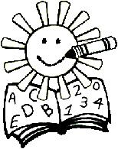 | Trinity UCC Preschool  2340 State Street  East Petersburg, PA 17520  569-1632 569-0592
CAR RIDER FORM

Child’s Name _______________________________ Class____________________

Parent(s)’ Name(s)_________________________________________________________

My child will be picked up by:

Name Phone # Relationship to Child

1. ________________________ _______________ _______________

2. ________________________ _______________ _______________

If something should change, I will send in writing (or email my teacher and cc Director) the name, phone number, and relationship to my child, of the person that has my permission to pick up my child that day.

_____________________________________ _______________
Signed Date

Tiny Tots: Tinytotsclass@trinityeastpete.org

2 Day: 2dayclass@trinityeastpete.org

3 Day: 3dayclass@trinityeastpete.org

4 Day: 4dayclass@trinityeastpete.org

Director: preschool@trinityeastpete.org

Purple

