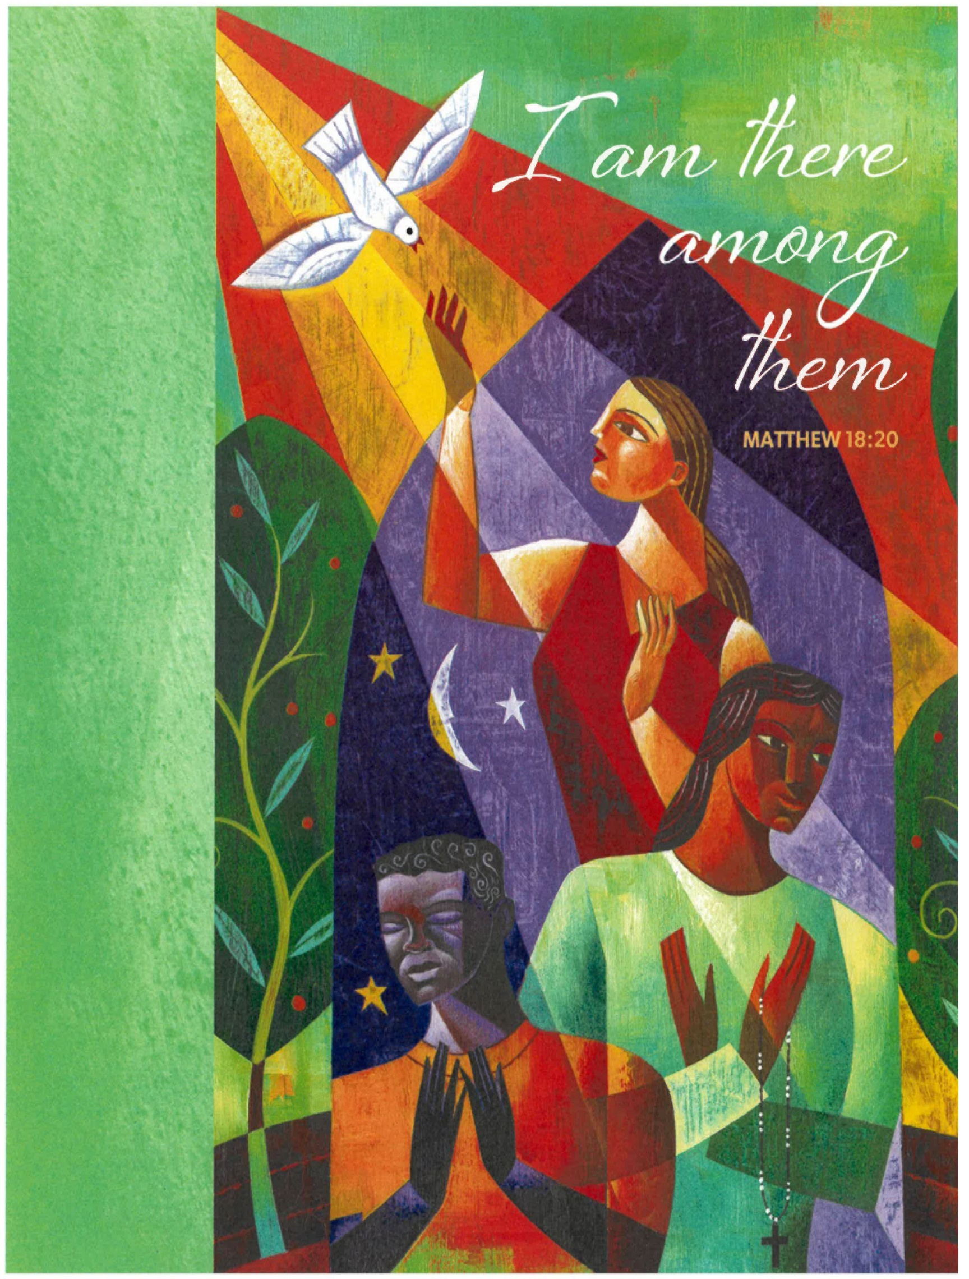

TRINITY UNITED CHURCH OF CHRIST
2340 State Street, East Petersburg, PA 17520
717-569-1632
Website: www.trinityeastpete.org E-Mail:secretary@trinityeastpete.org
The Rev. Dr. Christopher M. Rankin, Pastor
The Rev. Harry G. Royer, Pastor Emeritus
The Rev. Dr. Carolyne Call, Covenanted Minister of Mission
Mr. Michael Slechta, Director of Music/ Sounds of Trinity Choir Director
Mrs. Christine Oetama, Organist
Mrs. Carmen Richards, Pianist
Mrs. Carol Kratz, Administrative Assistant
Mr. Sean McKelvey, Preschool Director

Celebrating 175 Years: Honoring Our Heritage, Moving Forward in Faith!

Fifteenth Sunday after Pentecost
7:45 A.M. service

Today’s Theme: Conflict is a part of relationships and life in community. Jesus’ words in today’s gospel are often used in situations having to do with church discipline. The prophet Ezekiel tells of warning the wicked to turn from their ways, and Paul reminds us that love is the fulfilling of the law. We gather in the name of Christ, assured that he is present among us with gifts of peace and reconciliation.

Welcome all visitors! We welcome all who worship with us. May the joy of Christ’s presence and the power of the Holy Spirit fill you with peace and hope! We are honored by your presence and trust that you will join us in the praise and worship of God. Please sign our guest book in the narthex. If you are interested in church membership, please give your name and telephone number to Pastor Rankin.

Welcome to the Eucharist! All who seek to follow Jesus and who seek the gifts Jesus offers us are invited to share in this sacrament of Holy Communion. Children are invited to receive communion at the discretion of their parents/guardians. If a child wants to receive a blessing, they are asked to fold their hands.

Prayer As You Enter: O Lord God, enliven and preserve your church with your perpetual mercy. Without your help, we mortals will fail; remove far from us everything that is harmful, and lead us toward all that gives life and salvation, through Jesus Christ, our Savior and Lord. Amen.

PARISH ANNOUNCEMENTS

(Please stand if you are able)

CALL TO WORSHIP
Affirmation of baptism AND invitation to the table
In the Name of the Father, and of the Son, and of the Holy Spirit. Amen.

Praise God in the assembly of the faithful. Make melody to God and sing a new song.
Praise God for life enriched by love. Praise God for love that fulfills God’s law.
This is the hour to wake from our sleep. The energy of God’s love fills this place.
Here we claim our identity as Christians. Here we become the church of Jesus Christ.
As we come to the table of God’s heavenly feast, let us prepare our hearts anew to be in communion with one another and the risen Christ.
We come, ready to partake of bread and cup; ready to commune with one another and with the living God.
Jesus invites you to this table. Come, eat, and live.

CONFESSION OF SINS
CALL TO CONFESSION
Let us confess our sins to God, who is gracious and merciful, slow to anger, and abounding in steadfast love. (SEATED OR KNEELING)

silent confession of sins

Confession of sin
Let us bow before God in humility, confessing our sin.

Steadfast and faithful God, you have revealed the ways of justice, yet we fail to follow you. We are overwhelmed by the world’s violence and suffering. We are afraid to risk what we have for the sake of others. For the harm we have caused, known and unknown, forgive us. For the unjust demands we place on others and your creation, forgive us. For the ways we turn away from you and our neighbor, forgive us. Lead us back to you and set us on the right path; in the name of Jesus Christ, our Savior. Amen.

kyrie

Lord, have mercy. Lord, have mercy.
Christ, have mercy. Christ, have mercy.
Lord, have mercy. Lord, have mercy.

aSSURANCE OF PARDON
(Please stand if you are able)

adoration and praise
act of praise
O God, open my lips.
And my mouth shall proclaim your praise.
Praise to the holy and undivided Trinity, one God:
Glory be to the Father, and to the Son, and to the Holy Spirit, as it was in the beginning, is now and ever shall be, world without end. Amen.

COLLECT FOR the Fifteenth Sunday after Pentecost

Let us pray the collect together.
Eternal God, to whom we owe all we have and all we are, and whose law of love points to fulfillment in this life and beyond, show us how to live honorably and help us to make those choices that are pleasing to you, that your church may be a trusting community that leads many to lives of quality and realization, in Jesus’ name. Amen.
(please be SEATED)

the word of god
THE FIRST LESSON Ezekiel 33:7-11
God appointed Ezekiel as a sentinel for the house of Israel. Ezekiel must faithfully convey god’s warnings to the people. Remarkably, God-who is about to attack Jerusalem-gives a warning with the hope that repentance will make the attack unnecessary.

The Word of the Lord. Thanks be to God!

THE PSALTER Psalm 119:33-40
Teach me, O Lord, the way of your statutes, and I will observe it to the end.
Give me understanding, that I may keep your law and observe it with my whole heart.
Lead me in the path of your commandments, for I delight in it.
Turn my heart to your decrees and not to selfish gain.

Turn my eyes from looking at vanities; be gracious to me according to your word.
Confirm to your servant your promise, which is for those who fear you.
Turn away the disgrace that I dread, for your ordinances are good.
See, I have longed for your precepts; in your righteousness be gracious to me

THE SECOND LESSON Romans 13:8-14
The obligation of Christians is to love one another and so fulfill the heart and goal of the law. Clothes make the person as we “put on the Lord Jesus Christ” and live today in light of the future God has in store for us.

The Word of the Lord. Thanks be to God!

(Please stand if you are able)

THE HOLY GOSPEL St. Matthew 18:15-20
Jesus offers practical advice to his disciples on how individuals-and the church as a whole-should go about restoring relationships when one member has sinned against another.
Glory be to You, O Lord.

THE GOSPEL OF OUR LORD
Praise be to You, O Christ.

(please be seated)

SERMON “A Community of Grace’ Pastor Rankin

(Please stand if you are able)

U.C.C. STATEMENT OF FAITH
We believe in you, O God, Eternal Spirit, God of our Savior Jesus Christ and our God, and to your deeds we testify:

You call the worlds into being, create persons in your own image, and set before each one the ways of life and death.

You seek in holy love to save all people from aimlessness and sin. You judge people and nations by your righteous will declared through prophets and apostles. In Jesus Christ, the man of Nazareth, our crucified and risen Savior, you have come to us and shared our common lot, conquering sin and death and reconciling the world to yourself.

You bestow upon us your Holy Spirit, creating and renewing the church of Jesus Christ, binding in covenant faithful people of all ages, tongues, and races.

You call us into your church to accept the cost and joy of discipleship, to be your servants in the service of others, to proclaim the gospel to all the world and resist the powers of evil, to share in Christ's baptism and eat at his table, to join him in his passion and victory.

You promise to all who trust you forgiveness of sins and fullness of grace, courage in the struggle for justice and peace, your presence in trial and rejoicing, and eternal life in your realm which has no end.

Blessing and honor, glory and power be unto you. Amen.

PEOPLE’S OFFERING
OFFERING DEDICATION
May these offerings help to free your people, O God, from bondage to sin. Unite us in a community of mutual caring in which differences are resolved as we listen to one another and seek to offer understanding. May the light of your love shine through all our efforts to share your good news. Keep us in the light when we are tempted to ignore and violate your commandments. With these prayers, we dedicate our gifts in the name of Jesus Christ. Amen.

THE eucharistic prayer
The Lord be with you.
And also with you.
Lift up your hearts.
We lift them up to the Lord!
Let us give thanks to God Most High.
It is right to give God thanks and praise.

Holy God, our loving Creator, close to us as breathing and distant as the farthest star, we thank you for your constant love for all you have made. We thank you for all that sustains life, for all people of faith in every generation who have given themselves to your will, and especially for Jesus Christ, whom you have sent from your own being as our Savior. We praise you for Christ’s birth, life, death, and resurrection, and for the calling forth of your church for its mission in the world. Gifted by the presence of your Holy Spirit, we offer ourselves to you as we unite our voices with the entire family of your faithful people everywhere.
Holy, holy, holy God of love and majesty, the whole universe speaks of your glory, O God, Most High. Blessed is the one who comes in the name of the Lord. Hosanna in the highest!

(Please BE SEATED)

WORDS OF INSTITUTION AND PRAYER OF CONSECRATION

The prayer of our Lord
Our Father, who art in heaven, hallowed be thy name. Thy kingdom come. Thy will be done, on earth as it is in heaven. Give us this day our daily bread. And forgive us our debts, as we forgive our debtors. And lead us not into temptation, but deliver us from evil. For thine is the kingdom, and the power, and the glory, for ever. Amen.

breaking of the HOST & pouring of the cup
As this grain was once scattered in the fields, and has come together in one bread, so we, with different needs and hopes, come together as one, for we share one bread.
The Bread of Life, broken for us.

The cup which we share is the cup of the New Covenant written in our hearts and witnessed by Jesus.
The Cup of Blessing, poured out for us and for the many.

(Those who wish to come forward will be invited by the pastor. The pastor will serve you the host, saying, “The Body of Christ.” You reply, “Amen!” The assistant will present you with the cup, saying, “The Blood of Christ.” You reply, “Amen!” Grape juice is in the chalice with the cross and wine is in the other chalice. If you need the pastor and assistant to come to you, please indicate that to someone near you or the pastor. If you do not wish to come forward, you are invited to use the packaged elements in the narthex and commune in your pew. The pastor will offer a blessing everyone has communed. Children are invited to receive communion at the discretion of their parents/guardians. If a child wants to receive a blessing, they are asked to fold their hands.)

(Please stand if you are able)

POST COMMUNION PRAYERS
The Lord be with you.
And also with you.
In peace, let us pray to the Lord.

Remembering the caring and generous works of God, we pray for the church, creation, and the needs of our neighbors.

Hold us accountable, O God. Show your church where repentance is needed and lead us in paths of intentional compassion and listening. Help us extend hands of reconciliation and care, especially in relationships with other Christians and people of other faiths. Merciful God, receive our prayer.

Reveal your miracles to us, O God. Move us to cherish you as we behold the wonders of creation. Renew the seas and the soil, the forests and the creatures that live in them. Turn us to ways of living that seek Earth’s thriving. Grant strength and peace to those impacted by recent disasters. Merciful God, receive our prayer.

Inspire us to lead with honor, O God. Guide judges and legislators, police, and government officials to create and uphold just laws. Move us to treat all people with dignity and guide our conversations with one another. Merciful God, receive our prayer.

Awaken us, O God. Challenge and encourage your people to value the vocation to which each is called. We pray for all discerning new possibilities or changing employment. In all our diverse callings, teach us to love our neighbor above all else. Merciful God, receive our prayer.

Help us comfort those who suffer, O God. Reassure any who are harmed by the wicked acts of others. Bring peace to all who are vulnerable, frightened, despairing, or sick. Guard their waking and their sleeping. Merciful God, receive our prayer.

SILENT PRAYER
Let us pray together.
Blessed be your name, O God, for we have feasted on your Word, Christ Jesus, the joy and delight of our hearts. Strengthened by this food, send us to gather the world to your banquet, where none are left our and all are satisfied. In Jesus’ name we pray. Amen.

close of worship
BENEDICTION

CATCH THE VISION & SHARE THE JOY

ANNOUNCEMENTS
The Chancel Flowers are given by Jerry & Carmen Richards in honor of our 68th wedding anniversary.

The Worship Aids are given by Jerry & Carmen Richards in honor of our family.

Attendance for Sun., September 3 7:45–16 9:30–57 TOTAL – 73

Ministering Today
Pastor Rev. Dr. Christopher Rankin
Lector Rev. Jack Esbenshade
Money Counters Ron & Donna Denlinger, Steve Shenk, Bob Bistline
Altar Guild Nancy Enders, Hedwig Hunsicker, Karen Olley, Sally Rodenberger
Building Trustee Dave Connor
Ministries Card Children’s Sunday School Class
Called to Care Nancy Enders
Visitation Anita Rohrer

Happy Birthday
Tuesday – Michael Wagner, Dr. Rebecca Wagner
Wednesday – Mary Witmer
Thursday – Denise Huggins, Christine Oetama
Friday – Dr. Scott DeLong

This Week at Trinity Church
(Church Office Hours: Monday-Friday 9:00 a.m.-2 p.m.)
Monday 7:00 PM - Choir
Tuesday 7:00 PM – Property Committee
Wednesday 5:15-6:45 PM – Music Committee in Sanctuary
7:00 PM – Finance Committee
Saturday 8:00 AM – Men’s Breakfast at Family Fare
7:00 PM – Alanon/8:00 PM - AA
Sunday 7:45 AM – Eucharist
9:00 AM – Sunday School
10:00 AM - Koinonia
10:30 AM – Eucharist

PRAYERS FOR GOD’S HEALING PRESENCE
MEMBERS
Dr. Blaine Connor Dr. Carrie Call Scott & Jane Owens
Dave Trostle John Shelsky Dorothy Fasnacht
Bud McCarty Don & Pat Miller Dr. Janet Harriger
The Lehman family Joann Peck The Shelly Family
Donna Wolf & Family Ron Becker Mary Lou Shaab
Stan & Pat Seachrist Donna Zirkel Carmen & Jerry Richards
Rev. Dave & Mid Gockley Sam Minder III Lainie Christensen
Rev. Bob & Nancy Musser Hank Fox Charles & Betty Booraem
Betty Tyndall and family Nancy Patton Bob & Marlyn Wible
Rev. Bob & Judie Bistline Mary Witmer Kathleen Sensenig Adams
Rev. Jere & Judy Chapman Erika Otthofer Danielle Huggins Holbein
Joann & Dawn Garvin Ken & Phyllis Zimmerman

FAMILY & FRIENDS
The family of John Amentler (brother-in-law of Bob & Marlyn Wible)
The family of Lee Manifold (father of Marcia Eisenhour)
The Family of Rev. John Saxton (seminary friend of Rev. Bob Hunsicker)
Dr. Lee Barrett (Lancaster Seminary Professor)
Andrea Paulukow (daughter of John & Sarah Paulukow)
Richard Paulukow (relative of John & Sarah Paulukow)
Jaden Allen (nephew of Carol Kratz)
Cindy Commero Cook and family(friend of Sarah Paulukow)
Gina McCarty (daughter-in-law of Bud & Kathy McCarty)
The Bruno family (friends of Blaine Connor)
Jessica Brown (niece of Mike & Shelley Wagner)
Janice Zimmerman (sister of Ken Zimmerman)
Larry Gerlach (brother of Dolly Barr)
James Michaud (Sevi Keares’ teacher)
John Martin (brother-in-law of Dolly & John Barr)
Kelly Quick (friend of Rev. Dr. Rich & Lainie Christensen)
Marianne Gibble (friend of Trinity)
James Malone & family
Tom & Elaine Lichtenwalner (parents of Mike Lichtenwalner)
Janet Owens (sister-in-law of Scott & Jane Owens)
Chad Zirkel (son of Donna Zirkel)
Jordan Sensenig (grandson of Pat & Joan Sensenig),
Don Pfeifer (husband of Denise Pfeifer)
Rev. Phyllis Baum (former member of Trinity Church)
Jake & Jean Otthofer (parents of Dan Otthofer)
The Martin family
Robert Richards (brother of Jerry Richards)
Ronald Himelwright (grandson of Brenda & Harry Himelwright)
Barry Richards(son of Jerry & Carmen Richards)
Tyler Miller (grandson of Iris DeMaio)
Joan Kalbach (mother of Dr. Cathy Hoshauer)
Jim & Kathy Long (friends of Jerry & Carmen Richards)
John Siebern (Bob Siever’s brother-in-law)
Jo Jo Richards & family (Carmen & Jerry’s granddaughter-in-law)

THE SEPTEMBER PARISH POST is available on both floors of the church building.

DEVOTIONALS: The July-September edition of These Days are available on the table across from the church office or on the lower level by the portico entrance.



- The Children's Class will meet in the lower classroom and will be using the Spark lectionary based curriculum. These Sunday school lessons connect kids with Bible stories heard in worship. The Bible story have lessons that are packed with activities, interactive games, and creative crafts. Fall Year A covers Jesus’ teachings and parables in 11 lessons for Pentecost.

- Adult/Youth Bible Class will be studying The Way: Walking in the Footsteps of Jesus by Adam Hamilton. Using historical background, archaeological findings, and stories of the faith, Adam Hamilton retraces the footsteps of Jesus from his baptism to the temptations to the heart of his ministry, including the people he loved, the enemies he made, the parables he taught, and the roads he traveled. The class will meet in Isenberg Hall and will be led by Sue Bowman and Pastor Rankin. There will be opportunities for the youth to have breakout sessions during the class.

- The Wired Word (Christian Issues Today) Adult Class will meet in the Choir Room. Each week they will have a Bible study lesson linked to the latest headlines and current events using appropriate scriptures. Students can opt in or out of receiving the lesson by email before Sunday. To opt in before the first session, contact Diane Rice with your email address

PRAYER SHAWL: Prayer Shawl will meet Tuesday, September 19 from 1:00-3:00 PM. They will continue to meet on the third Tuesday of each month! Come and bring a friend. Hope to see many of you there! Contact Betty Tyndall for more information.

Men of Trinity (M.O.T.) Breakfast: The monthly breakfast will be held at the Family Fare Restaurant on September 16 at 8:00 a.m. Look for the sign-up sheet on the table across from the church office. This is open to the men of Trinity! You can always invite a friend to join you for breakfast!

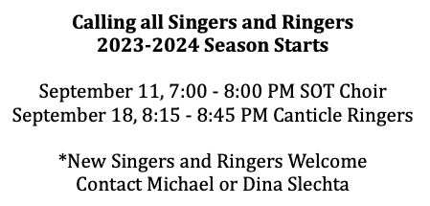

LOOK FOR THE SIGN-UP SHEET ON TABLE ACROSS FROM THE OFFICE!

TRINITY PRAYER BOOK: In the spring, participants in the Adult Sunday School Class were sharing prayers that were meaningful to their family. Anne Rankin thought it would be good to compile these prayers and create a Trinity prayer book as part of our 175th anniversary. You can submit prayers to Pastor Chris or Anne.

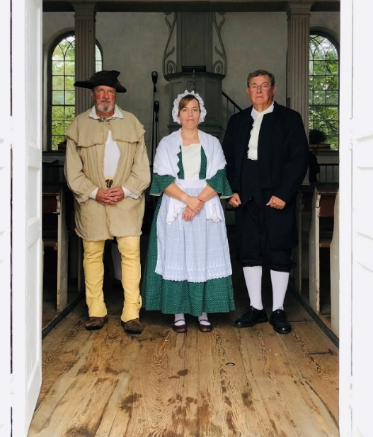
Old German Reformed Church Anniversary Service
On Sunday, September 10, 2023, at 3:00 p.m., Old Zion German Reformed Church, Brickerville, will conduct an annual anniversary service. The service provides an opportunity to reflect on Old Zion’s rich history and faith traditions.

This year’s theme will be “Moravians: Threat or Salvation,” and will explore the sometimes contentious, sometimes compatible faith relationships between members of the German Reformed and Moravian Churches in the Eighteenth Century. The German Reformed Church is an early predecessor of the modern United Church of Christ. The theme reflects the historical controversy between members of the Moravian and Reformed Churches, who competed for the attention of believers as they established congregations throughout Central Pennsylvania. That controversy has long since passed, as reflected in the recent merger of the Lancaster Theological Seminary and the Moravian Seminary.
Rev. William LaSalle will portray a Reformed pastor of Old Zion in the mid-1700s. Dr. Lee Barrett, Professor of Systematic Theology at Lancaster Theological Seminary, will explore the theme in his sermon by the same title. The worship service will include music and hymns from the period and will feature the Ephrata Cloister Chorus under the direction of Dr. Mark Herr. The Cloister Chorus will sing songs from the Ephrata Cloister along with music from the Reformed and Moravian traditions. J.P. Welliver, Director of Music at St. Paul Lutheran Church, Penryn, will play the historical pump organ at Old Zion as part of the service.
Please join us for an afternoon of faith, music, history, and fellowship. Refreshments will be served after the service. Old Zion German Reformed Church is located near Brickerville at 187 Reifsnyder Rd.

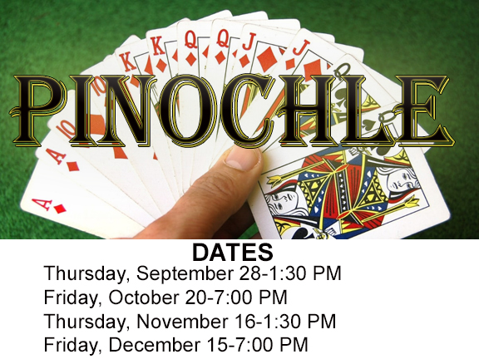

COMMUNITY MEAL MINISTRY
Trinity's next community meal will be Tuesday, September 26-5:00 PM at First Reformed U.C.C. (40 E. Orange St., Lancaster). Volunteer and donation sign-up sheets are on the table across from the church office. Trinity will be serving chicken and waffles. Thanks for your continued support serving a meal to those who are in need. Contact Kathy Cooley for more information!

Koinonia/sundaymorning fellowship
We have resumed koinonia (community fellowship) every Sunday at 10 a.m. in Isenberg Hall. Volunteers are asked to provide light refreshments and drinks/coffee. The sign-up sheet is on the kitchen coordinator. If you have any questions, contact Paula Dennes. Coffee is always available between 7:45 service and Sunday School.


AMERICAN MUSIC THEATRE Outing
2425 Lincoln Hwy East, Lancaster, PA
December 16, 10:30 AM
Cost: Adults-$43, Youth-$22
Christmas Show: The First Noel
Deadline to sign-up is October 15.
Signup sheet on table in hallway outside office.

Share Your Stories/Memories of Trinity Church: The 175th Anniversary Committee invites members of the congregation to share your stories and memories of Trinity Church for our November Echoes of the Past article. What are some of the things you remember from our past? Who are some of the people you remember? For some of our newer members, what drew you to Trinity Church? Whether you have been here 50 years or you recently joined, we want to hear from you!! Please submit your stories/memories to the church office by October 6.

175th Anniversary Service/Luncheon at Blue Collar
October 29
Service is 10:30 and luncheon at 12:30!
The Rev. Dr. Carrie Call, Guest Preacher

Menu (you will choose one):
--Barbecue Chicken (tangy vinegar-based barbecue sauce), fries, and green beans
--Salmon with citrus sauce, farro, and green beans
--Stuffed Pork Loin (port wine sauce) rosemary potatoes, and green beans
All meals will include assorted rolls, drinks (tea, water, coffee), and dessert
Children's menu: cheeseburger, mac & cheese, and chicken bites with fries.
Price: $20 for adults/$7 for children (Trinity will pay the other portion of the meal price)
Tickets will be sold from September 10 through October 13!

The committee is ordering shirts through Mitch Gibson (from Elizabethtown Sporting Goods) to celebrate our 175th anniversary. Watch for details in the bulletins about ordering your Trinity shirt.

Contact a committee member for more information: Dolly Barr, Rev. Dr. Rich Christensen, Donna Geisler, Diane Rice, or Pastor Rankin.
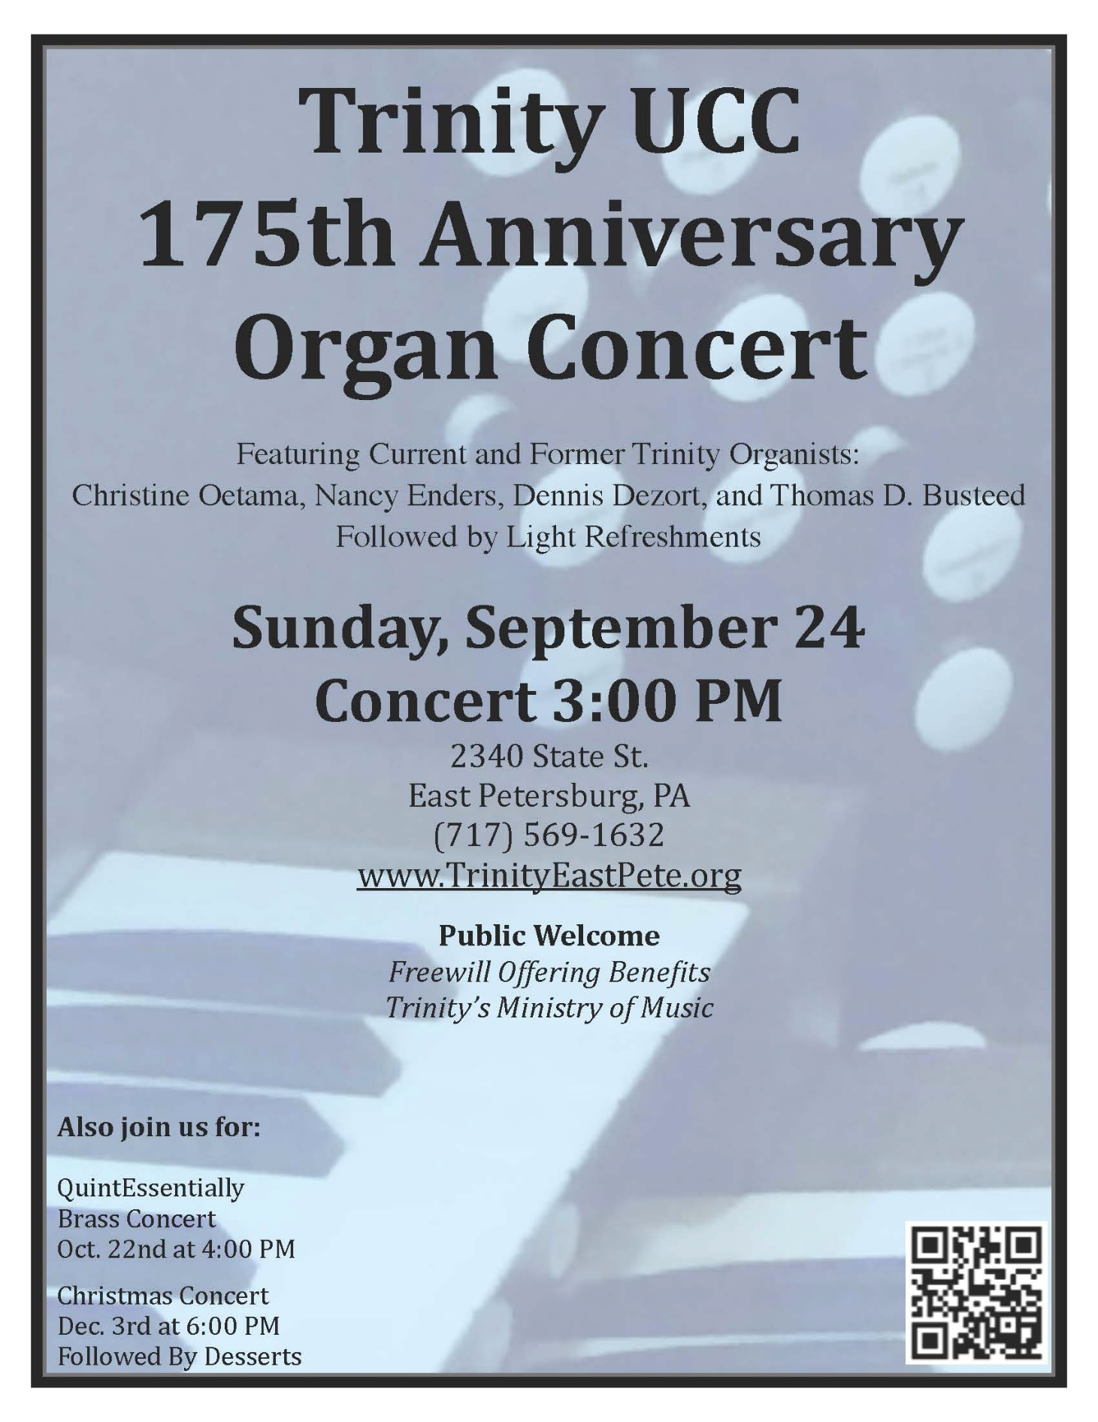


YOUR HELP IS NEEDED!
Greeter /Ushers Needed
If you would like to volunteer as a Greeter/Usher for the 10:30 a.m. service please contact the church office. We recently had some vacancies as ushers, so we are in need of help!!!
We are looking for a greeter coordinator that will recruit new people to serve and create a schedule. Contact Pastor Chris or Carol Kratz.


Assist with the worship service or to just read the scripture lessons at the 7:45 a.m. and 10:30 a.m. services. Please contact Pastor Chris or Carol Kratz if you are willing to volunteer!

2023 CHANCEL FLOWERS AND WORSHIP AID SPONSORS: Upcoming dates for chancel flowers are: December 17 & 31. Upcoming dates for worship aids are: November 5, 19 & 26. The price for flowers is $60. The price for worship aids is $26. Look for the charts on the bulletin board in the narthex or call Carol in the church office.

Mark & Chris Eyer are serving as our coordinators again this year!. Pastor Chris is looking for one or two people to attend a CROP Walk Rally on Saturday, September 16 from 10-11:30 a.m. at the Church World Service office (439 E. King St., Lancaster) If interested, speak to the pastor.

You can register to walk or donate to our team at https://events.crophungerwalk.org/2023/team/trinity-east-pete

