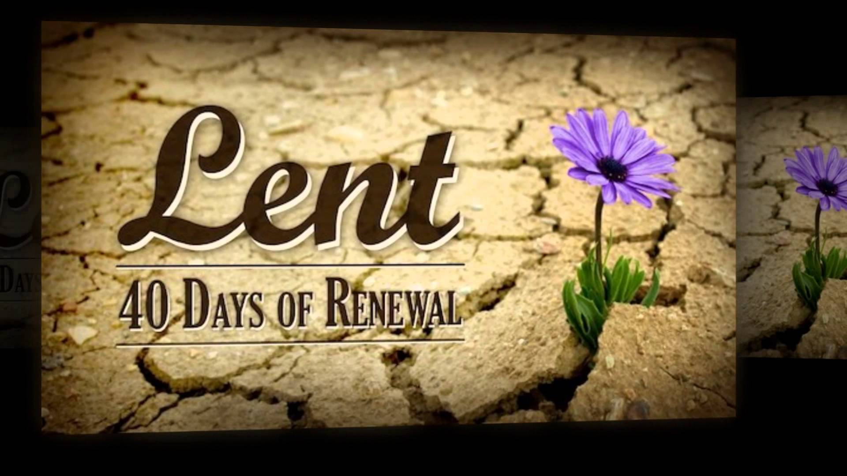



**April 5, 2023**

**7:00 p.m.**

**SING WITH ALL THE SAINTS IN GLORY**

***Week 6 of Lent: The Beginning of Life***

***(Dietrich Bonhoeffer)***

**Isaiah 50:4-6**

**Hebrews 12:1-3**

**Matthew 16:21-26**

**TRINITY UNITED CHURCH OF CHRIST**

2340 State Street, East Petersburg, PA 17520

717-569-1632

Website: www.trinityeastpete.org E-Mail:secretary@trinityeastpete.org

The Rev. Dr. Christopher M. Rankin, Pastor

The Rev. Harry G. Royer, Pastor Emeritus

The Rev. Dr. Carolyne Call, Covenanted Minister of Mission

Mr. Michael Slechta, Director of Music and SOT Choir Director

Mrs. Christine Oetama, Organist

Mrs. Carmen Richards, Pianist

Mrs. Carol Kratz, Administrative Assistant

Mr. Sean McKelvey, Preschool Director

**holy wednesday**

**The Order For Reconciliation, Anointing, and Healing**

Lent is a time of renewal. We focus on the death and resurrection of Jesus and in turn focus on our own death and resurrection found in baptism. We who have been baptized into Christ have died to sin and are righteous saints of God. At the same time, we know that we struggle daily with sin as we seek to follow Jesus. This is the wonderful understanding of sinner and saint.

We have a rich calendar of saints in the Christian faith. These are people from every age who have pointed to Christ in their living and dying. In remembering these Christians who have gone before, we find inspiration for our Christian journey. This Lenten midweek series honors the commemorations that occur during the weeks of the Lenten season. Commemorating these individuals is a starting point for a deeper engagement with our Christian faith.

**This week’s commemoration –Dietrich Bonhoeffer was a German theologian who, at the age of twenty-five, became a lecturer in systematic theology at the University of Berlin. In 1933, and with Hitler’s rise to power, Bonhoeffer became a leading spokesman for the Confessing Church, a resistance movement against the Nazis. He was arrested in 1943. He was linked to a failed attempt on Hitler’s life and sent to Buchenwald, then to Schönberg prison. After leading a worship service on April 8, 1945, at Schönberg prison, he was taken away to be hanged the next day. His last words as he left were, “this is the end, but for me the beginning of life.”**

**Welcome all visitors!** We welcome all who worship with us. May the joy of Christ’s presence and the power of the Holy Spirit fill you with peace and hope! We are honored by your presence and trust that you will join us in the praise and worship of God.

**Why no alleluias or hymns of praise during Lent?** You may have noticed that the hymn of praise following the assurance of forgiveness is missing from our worship. We join other churches in omitting alleluias, glorias, and other hymns of praise as we turn again to our Lenten journey of exile and repentance. We long for the eschatological New Jerusalem "...the Jerusalem above; she is free, and she is our mother" (Galatians 4:26). We walk in darkness awaiting the city of God where... "there will be no more night; the servants of God need no light of lamp or sun, for the Lord God will be their light, and they will reign forever and ever" (Revelation 22:5). Until then, we travel with our Lord Jesus into the desert to face the devil, we join him in his triumphant procession into Jerusalem, we pray with him in the garden of Gethsemane, and we follow him to the painful cross and to the cold dark tomb. We trust that our journey with Christ does not end there. On Easter we once again join the praises of the choirs of heaven: "The Lord is risen; the Kingdom has come; our joy is complete; and, in concert with the angels and saints, we greet the risen Lord with shouts of 'Alleluia!'"

(http://catholicism.about.com/od/worship/f/No_Alleluia.htm).

**From Dietrich Bonhoeffer (*By Gracious Powers*):**

*By gracious powers so wonderfully sheltered, and confidently waiting come what may, we know that God is with us night and morning, and never fails to greet us each new day.*

*Yet is this heart by its old foe tormented, still evil days bring burdens hard to bear; oh, give our frightened souls the sure salvation, for which, O Lord, you taught us to prepare.*

*And when this cup you give is filled to brimming with bitter suffering, hard to understand, we take it thankfully and without trembling out of so good and so beloved a hand.*

*Yet when again in this same world you give us the joy we had, the brightness of your sun, we shall remember all the days we lived through and our whole life shall then be yours alone.*

*By gracious powers so faithfully protected, so quietly, so wonderfully near, we live each day in hope, with you beside us, and go with you through ev’ry coming year.*

**PRELUDE** *O Sacred Head, now Wounded (Herzlich Tut Mich Verlangen)*

**D. Buxtehude**

*(Please use the prelude as a quiet time to begin worship)*

**PARISH ANNOUNCEMENTS**

*(Please stand if you are able)*

**OPENING HYMN *O Jesus, We Adore Thee*  #162**

**CALL TO WORSHIP**

**Affirmation of baptism and Lenten versicles**

The love of God poured into our hearts, the saving grace of Jesus Christ, and the abundant life of the Holy Spirit be with you all.

**And also with you.**

Let us look to Jesus, the pioneer and perfecter of our faith,

**who for the joy that was waiting endured the cross.**

Despising the shame,

**and is seated at the right hand of the throne of God.**

O Jesus, we adore Thee,

**upon the cross, our King.**

Let us pray.

**God of all mercy and consolation, come to the aid of your people, turning us from**

**our sin to live for you alone. Give us the power of your Holy Spirit, that we may**

**attend to your Word, confess our sins, receive your forgiveness, and grow into the**

**fullness of Jesus Christ, the one begotten by you before all worlds, our Lord,**

**our Savior, and our Redeemer. Amen.**

**EXAMINATION**

*(kneeling or seated)*

Hear the commandments of God: I am the Lord, your God, who brought you out of bondage. You shall have no other gods before me. **God have mercy upon us and guide us in your way.**

You shall not make for yourself any idol.

**SILENCE**

You shall not invoke with malice the name of the Lord, your God.

**SILENCE**

Remember the Sabbath Day and keep it Holy.

**SILENCE**

Honor your father and your mother.

**SILENCE**

You shall not kill.

**SILENCE**

You shall not commit adultery.

**SILENCE**

You shall not steal.

**SILENCE**

You shall not bear false witness.

**SILENCE**

You shall not covet anything that belongs to your neighbor. **God have mercy upon us and guide us in your way.**

Jesus said, the first commandment is: **Hear, O Israel, the Lord, our God, is the only holy one, and you shall love the Lord your God, with all your heart, and with all your soul, and with all your mind, and with all your strength.**

The second commandment is this: **you shall love your neighbor as you love yourself.**

No other commandment is greater than these.

**Lord, have mercy upon us, and incline our hearts to keep all these laws.**

**PRAYER**

O God, the Father in heaven, **have mercy upon us.**

O God, the Son, Redeemer of the world, **have mercy upon us.**

O God, the Holy Spirit, Sanctifier of the faithful, **have mercy upon us.**

O holy, blessed, and glorious Trinity, ever one God, **have mercy upon us.**

Let us pray together.

**Merciful God, from whom come all holy desires and just works, breathe into our hearts by your Holy Spirit the gift of obedient faith, that we, knowing your will, may treasure these words in our minds and hearts, and may in all things love and serve you. Amen.**

*(Please stand if you are able)*

**service of the word**

**COLLECT**

**Gracious God, whose presence sustains us in the face of opposition, betrayal, and suffering, feed us now with your Word of life, that we may not succumb to temptation. Nourish us as disciples of Jesus Christ, so we may grow in faithfulness and witness to your saving love for all people. Amen.**

*(please be SEATED)*

**THE OLD TESTAMENT LESSON Isaiah 50:4-6**

The Lord God has given me the tongue of a teacher, that I may know how to sustain the weary with a word. Morning by morning he wakens—wakens my ear  
to listen as those who are taught. The Lord God has opened my ear, and I was not rebellious, I did not turn backwards. I gave my back to those who struck me,  
and my cheeks to those who pulled out the beard; I did not hide my face from insult and spitting.

The Word of the Lord. **Thanks be to God!**

**THE EPISTLE LESSON Hebrews 12:1-3**

Therefore, since we are surrounded by so great a cloud of witnesses, let us also lay aside every weight and the sin that clings so closely, and let us run with perseverance the race that is set before us, looking to Jesus the pioneer and perfecter of our faith, who for the sake of the joy that was set before him endured the cross, disregarding its shame, and has taken his seat at the right hand of the throne of God. Consider him who endured such hostility against himself from sinners, so that you may not grow weary or lose heart.

The Word of the Lord. **Thanks be to God!**

*(Please stand if you are able)*

**THE GOSPEL LESSON St. Matthew 16:21-26**

***Glory be to you, O Lord.* No. 498**

From that time on, Jesus began to show his disciples that he must go to Jerusalem and undergo great suffering at the hands of the elders and chief priests and scribes, and be killed, and on the third day be raised. And Peter took him aside and began to rebuke him, saying, ‘God forbid it, Lord! This must never happen to you.’  But he turned and said to Peter, ‘Get behind me, Satan! You are a stumbling-block to me; for you are setting your mind not on divine things but on human things.’

Then Jesus told his disciples, ‘If any want to become my followers, let them deny themselves and take up their cross and follow me. For those who want to save their life will lose it, and those who lose their life for my sake will find it.  For what will it profit them if they gain the whole world but forfeit their life? Or what will they give in return for their life?

**THE GOSPEL OF OUR LORD**

***Praise be to you, O Christ.* No. 498**

*(please be SEATED)*

**SERMON “Consider this Jesus” Rev. Dr. Rich Christensen**

*(Please stand if you are able)*

**APOSTLES’ CREED**

**I believe in God, the Father, the Almighty, Maker of heaven and earth.**

**And in Jesus Christ, his only begotten Son, our Lord, who was conceived by the Holy Spirit, born of the Virgin Mary, suffered under Pontius Pilate, was crucified, dead, and buried; he descended into hell; the third day he rose again from the dead; he ascended into heaven, and sits on the right hand of God the Father Almighty; from thence he shall come to judge the living and the dead.**

##### I believe in the Holy Spirit, the holy catholic church, the communion of saints, the forgiveness of sins, the resurrection of the body, and the life everlasting. Amen.

**HYMN *I Greet Thee, Who My Sure Redeemer Art*  #277**

*(please be SEATED)*

**PEOPLE’S OFFERING**

**CALL TO OFFERING**

**OFFERTORY *Go to Dark Gethsemane* W. Held**

*(Please stand if you are able)*

**Offering Response**  ***We Give Thee But Thine Own* #506**

**THE PRAYER OF OUR LORD**

**Our Father, who art in heaven, hallowed be thy name. Thy kingdom come. Thy will be done, on earth as it is in heaven. Give us this day our daily bread. And forgive us our debts, as we forgive our debtors. And lead us not into temptation, but deliver us from evil. For thine is the kingdom, and the power, and the glory, forever. Amen**.

**ACT OF CONFESSION**

**CALL TO CONFESSION**

To bear one another’s burdens in prayer is a holy privilege. It also demands a willingness to be a channel for God’s power. Therefore, in silence, let us offer our confessions to God that we may be cleansed of anything that might hinder our efforts as intercessors.

*(please be SEATED or kneel)*

**SILENT CONFESSION**

**CONFESSION OF SINS**

Let us confess together

**Gracious God, our sins are too heavy to carry, too real to hide, and too deep to undo. Forgive what our lips tremble to name, what our hearts can no longer bear, and what has become for us a consuming fire of judgment. Set us free from a past that we cannot change; open to us a future in which we can be changed; and grant us grace to grow more and more in your likeness and image; through Jesus Christ our Savior. Amen.**

**PRAYER FOR MERCY (TRISAGION)**

Holy God, Holy and mighty, Holy Immortal One, **Have mercy upon us.**

**ABSOLUTION**

In Christ’s name, and as one with you in the church, I declare to you: Your sins are forgiven!

**In Christ’s name, and as sisters and brothers in the church, we declare to you: your sins are forgiven! Thanks be to God!**

**THE ORDER FOR ANOINTING**

**PRAYERS OF INTERCESSION**

As we have confessed that which separates us from God, ourselves and one another and have received the promise of healing grace, so let us pray silently for all who need special healing.

**SILENT PRAYER**

*(name those in need of healing)*

O God of all comfort, our help in time of need, we humbly ask you in the power of your Holy Spirit to enter and heal your servants. Look upon them with your mercy; comfort them with the assurance of your care and goodness; save them from temptation and despair; give them patience under affliction; and enable them to place themselves in your hands of grace so that they may know and experience the peace of our Lord Jesus Christ, who came that we may have life and have it more abundantly. **Amen.**

**THANKSGIVING OVER THE OIL**

*(please be SEATED)*

**WORDS OF INVITATION**

**ACT OF ANOINTING**

**HYMN DURING ANOINTING *Heal Me Hands of Jesus***

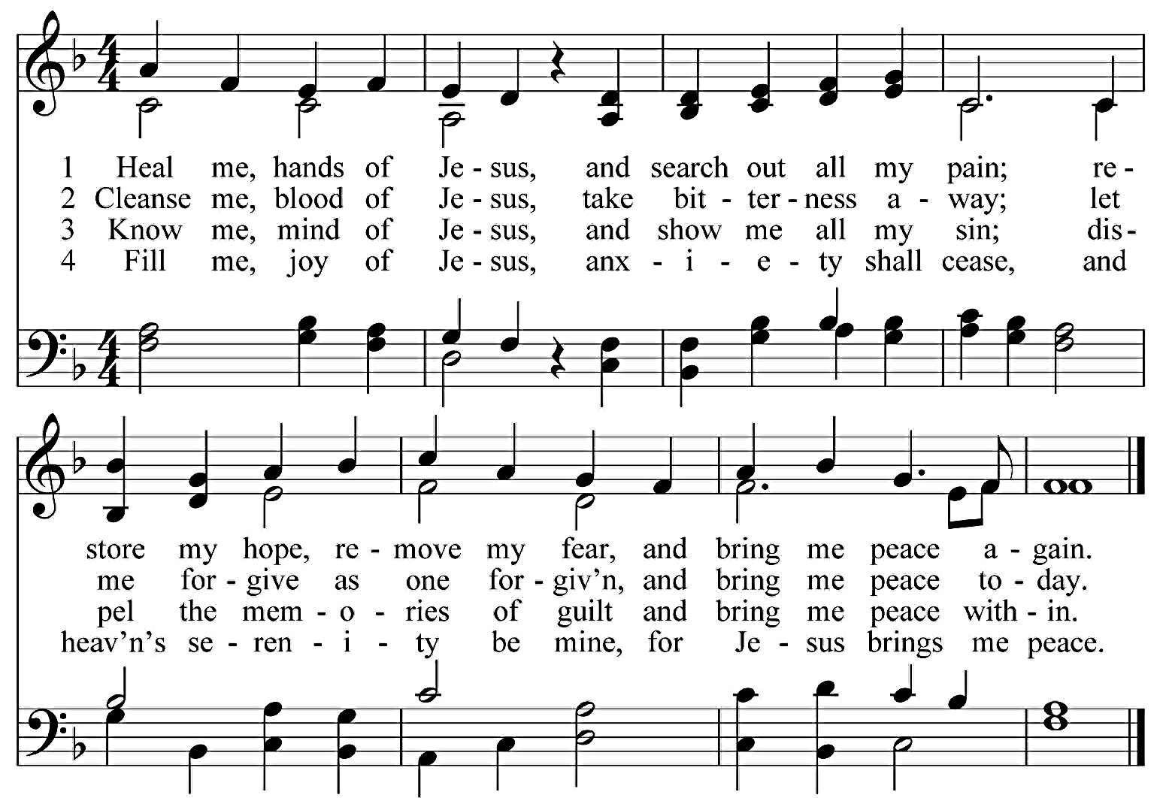

*(Please stand if you are able)*

**PRAYER OF THANKSGIVING**

**We thank you for our Lord Jesus Christ who has given us life; brought ministry, forgiveness, healing, and peace; commanded the disciples to heal the sick; and continued the healing ministry to this day. Keep us mindful of your love and mercy that we may be faithful throughout all our days. In his name we pray. Amen.**

**close of worship**

**HYMN *O the Deep, Deep Love of Jesus***

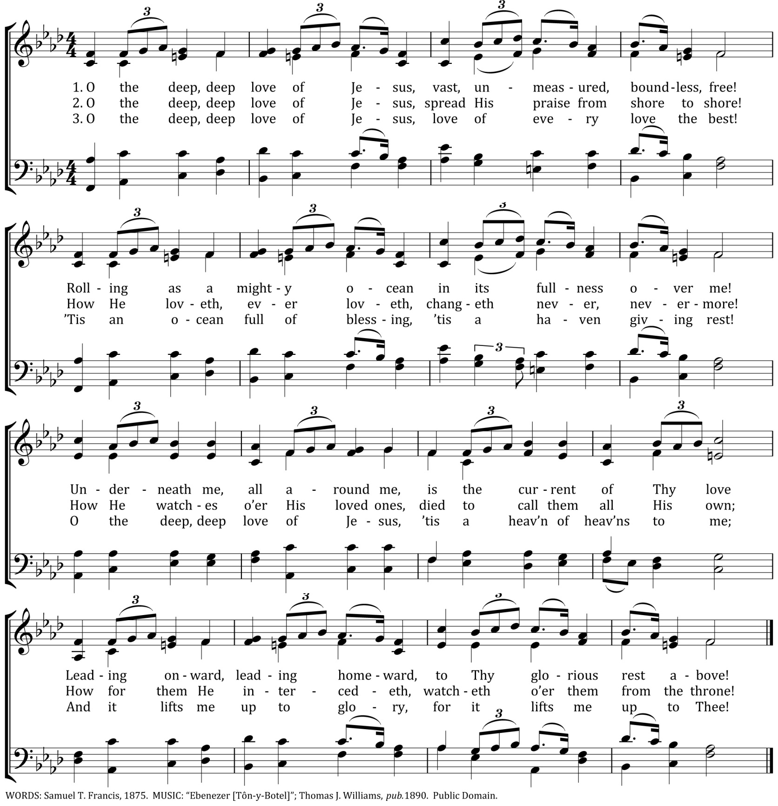

*(please be SEATED)*

**musical MEDITATION**

**BENEDICTION**

**POSTLUDE *Fughetta in G Minor* G. Merkel**

**CATCH THE VISION & SHARE THE JOY**

**Ministering This Evening**

Liturgist: Rev. Dr. Christopher Rankin

Preacher: Rev. Dr. Richard Christensen

Building Trustee: Hank Fox

Ushers/Greeters: **Mike Wagner,** Kathy McCarty, Betty Tyndall

**We welcome the Rev. Dr. Richard Christensen, a member of Trinity Church, as our guest preacher. Dr. Christensen is a graduate of Lancaster Theological Seminary and was ordained on June 7, 1970. He has participated in the life of Trinity Church as a lector, an adult Sunday School teacher, and the Children & Eucharist Task Force. Dr. Christensen is involved with the Mercersburg Society. He has served the following ministries:**

1998-12 Associate Professor of Philosophy and Religion; Director of the Mission House Center for Theology, Lakeland College

1992-98 Professor of Church History, Phillips Theological Seminary

1988-92 Ph.D. in Church History, Union Theological Seminary (VA)

1983-88 Pastor, Salem U.C.C., Campbelltown

1980-83 Chaplain & Teacher of Religious Ed., Maun Secondary School, Botswana

1974-80 Pastor, St. Peter’s U.C.C., State College

1972-74 Pastor, Congregational U.C.C., Amherst, OH

1971-72 Assistant Pastor, Faith U.C.C., State College

1970-71 Assistant to Director of Development, Lancaster Theological Seminary

1970 Summer Pastor, First Congregational U.C.C., Brookfield, VA

**THE APRIL PARISH POST** is available on both floors of the church building.

**DEVOTIONALS:** The April-June edition of These Days are available on the table across from the church office or on the lower level by the portico entrance.

**LENTEN DENIAL ENVELOPES:** The Board of Deacons decided to divide the donations in the Lenten denial envelope to assist those impacted by the war in Ukraine and the earthquake in Syria and Turkey. Please be generous as we help our brothers and sisters in need.

**HOLY WEEK & EASTER SERVICES**

**MAUNDY THURSDAY (April 6 at 2 p.m./7 p.m.):** Service of Word & Sacrament with Pastor Rankin preaching. The 2 p.m. service will be streamed on our Facebook page and later uploaded to our website.

**GOOD FRIDAY TENEBRAE SERVICE (April 7 at 7 p.m.)**

**EASTER MORNING SCHEDULE:**

**6:30 a.m.—**Sunrise Service in the parking lot with Holy Communion

**8:00 a.m.—**Service in the sanctuary with Holy Communion (will be streamed on Facebook and later uploaded to our website)

**9:15-10:00 a.m.—**Breakfast in Isenberg Hall **(sign-up sheet is on the table across from the church office)**

**10:30 a.m.—**Service in the sanctuary with Holy Communion

**CHURCH MULCHING:** The Property Committee is looking for volunteers on Saturday, April 15 @ 8:30 am to mulch the church property. The rain date is April 29.

**PRESCHOOL MYSTERY READERS:** Trinity Preschool is looking for Spring Mystery Readers for the remainder of March and April.  Please contact Sean McKelvey through the church office or email at [preschool@trinityeastpete.org](mailto:preschool@trinityeastpete.org) to schedule a time to read a book to a preschool class.  It’s a fun way for Trinity members to support and be part of our preschool.





**KNIT IN GOD’S LOVE PRAYER SHAWL MINISTRY:** The Prayer Shawl will meet Tuesday, April 18 from 1:00-3:00 PM. They will continue to meet on the third Tuesday of each month! Come and bring a friend. Hope to see many of you there! Contact Betty Tyndall for more information.

**CALLED TO CARE MINISTRY:** The Evangelism Committee has revitalized the Called to Care ministry.   Meals will be provided for members after they have returned home from the hospital or during other critical moments.  Transportation to medical appointments is also available.  Nancy Enders will be the coordinator for April.

**The Lancaster County Climate Summit** is a community-focused event for everyone to come together to advance climate awareness and take action in Lancaster County.  Presentations on various will occur throughout the day at the following locations:

**1. Information Pop-Up/Talking Circle:**Penn Square-Fulton Bank

**2. Ware Center (42 N. Prince St.):**Climate Overview/Finances

**3. Tellus360 (24 E. King St.):**Home Energy/Buildings & Cities/Materials

**4. Holy Trinity Lutheran Church (31 S. Duke St.):**

Transportation/Faith Based Climate Action---Pastor Chris will be presenting information about the Come Follow Me Retreat/Adult Elective

**5. St. James Episcopal Church (119 N. Duke St.):**Food & Land

**6. First Presbyterian Church (140 E. Orange St.):**Water

**7. First Reformed U.C.C. (40 E. Orange St.):**Health, Climate Justice

More information can be found at [https://regenall.org](https://regenall.org/)

**welcome luncheon:** The Evangelism Committeewill be sponsoring a welcome luncheon for new members and recent visitors to Trinity Church following the 10:30 service on April 30th.  Look for the sign-up sheet across from the church office.



**COMMUNITY MEAL:** Trinity will be cooking and serving a take-out community meal at **Zion Evangelical Lutheran Church at 85 Brandt Blvd in Landisville on Thursday, April 13th at 5:30 PM.**

Persons are needed to help with meal preparation and to hand-out the take-out meals. Sign-up sheets for helpers are posted in the Narthex. Persons helping to prepare the meal need to arrive at Zion Lutheran by 4:00 PM. Persons helping to hand-out the meals need to arrive at Zion Lutheran by 5:00 PM. Contact Nancy Enders or Paula Dennes with questions. Thank you for your continued support of this important mission.

**2023 CONCERT SPONSORS:** Forms are available on the table across from the church office for you to sponsor this year’s concert series.

