PRESCHOOL NEWSLETTER

Trinity United Church of Christ

JANUARY 2023

HAPPY NEW YEAR!

Welcome to a new year at the school! As the children get re-acquainted with school since their holiday vacation there may be some bumps on the road, but back in the swing of the schedule we’ll see some really big jumps in learning! The children are forming friendships, learning how to cope with a variety of situations and people, and developing confidence to last a lifetime! We are so glad you are a part of our preschool!

SNOW DAYS
When Hempfield School District is closed, we will be closed. When they have a delayed start, we will have our modified schedule and meet 10:30-12:30; Enrichment Class is 12:30-2:30. Tiny Tots will meet 10:30-12:00. Lunch Bunch 12:30-2:00.

TUITION PAYMENTS DUE
Semi-annual, third quarter and monthly tuition payments are due January 15th. Make checks payable to Trinity U.C.C. Preschool. Thank you!

REGISTRATIONS FOR 2023 - 2024
Registrations are accepted on a first come, first served basis. If you are interested in enrolling your child next year, please do not delay (to avoid disappointment.) Please spread the word to friends and neighbors! A registration form will be sent home to you. If you have made a referral, have that person note your name on their registration form and you will receive a rebate on your registration fee. Parents are our best advertisement! We appreciate you!

PRESCHOOL TAX NUMBER
Tax #23-1719341. If you are working while your child is in Preschool, you may be able to claim tuition. This is also the number to use when claiming a donation to the preschool.

3 and 4 Day classes Resume Monday, January 2
2 Day class resumes Tuesday, January 3
Enrichment resumes Wednesday, January 4
Tiny Tots class resumes Thursday, January 5
NO SCHOOL Monday, January 16th - Martin Luther King Jr. Day

INDOOR WINTER FUN
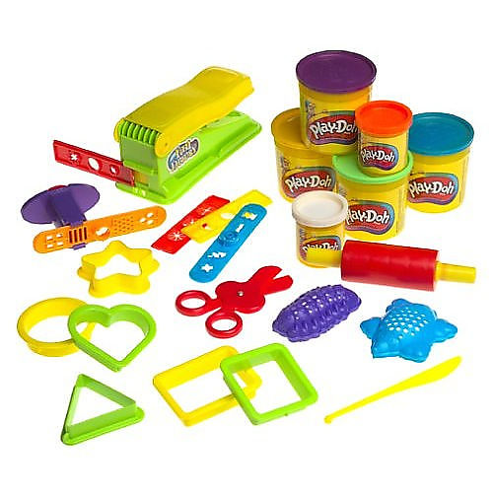
Your child will benefit greatly from participating in these activities with you at home. Remember, the benefit is in the process of doing, not the product created! Encourage your child in conversation with questions: How does it feel? What does it look like? How much or how many? Another fun interaction is to simply describe what you see your child doing. They will LOVE it.
*playing in shaving cream squirted on the table
*measuring trail mix goodies and stirring with your hands
*cutting out coupons
*dancing to music
*sorting piles of coins
*playing with play-dough

4-DAY CLASS WITH Mr Sean & MISS KELLY
We will explore snow and winter animals. We will also continue working on identifying letters and the sounds they make. Dice games which will help develop number sense will also be a part of our day.

3-DAY CLASS WITH Ms Karen & MRS. COX
Welcome back! We are ready for a new year of fun! Mittens, arctic animals, ice and igloos will all be part of our classroom while we work on letters. Lots of cool Science experiments will be happening this month.

2-DAY CLASS WITH Ms. Karen & MRS. COX
Welcome back to school – we missed you! The month of January will be filled with winter activities, polar bears and penguins. What fun!

TINY TOTS CLASS WITH MISS CRYSTAL & MISS KELLY
We will be exploring snowmen and bears. We will discover the color white and the shape of a star. We will also practice counting and build our fine motor skills.

“Play is our brain’s favorite way of learning.” -Diane Ackerman

HAPPY NEW YEAR FROM TRINITY UNITED CHURCH OF CHRIST

