Trinity U.C.C. Preschool

Handbook

2022-2023

2340 State Street
East Petersburg, PA 17520
PH: 717-569-1632

Sean McKelvey, Director

preschool@trinityeastpete.org

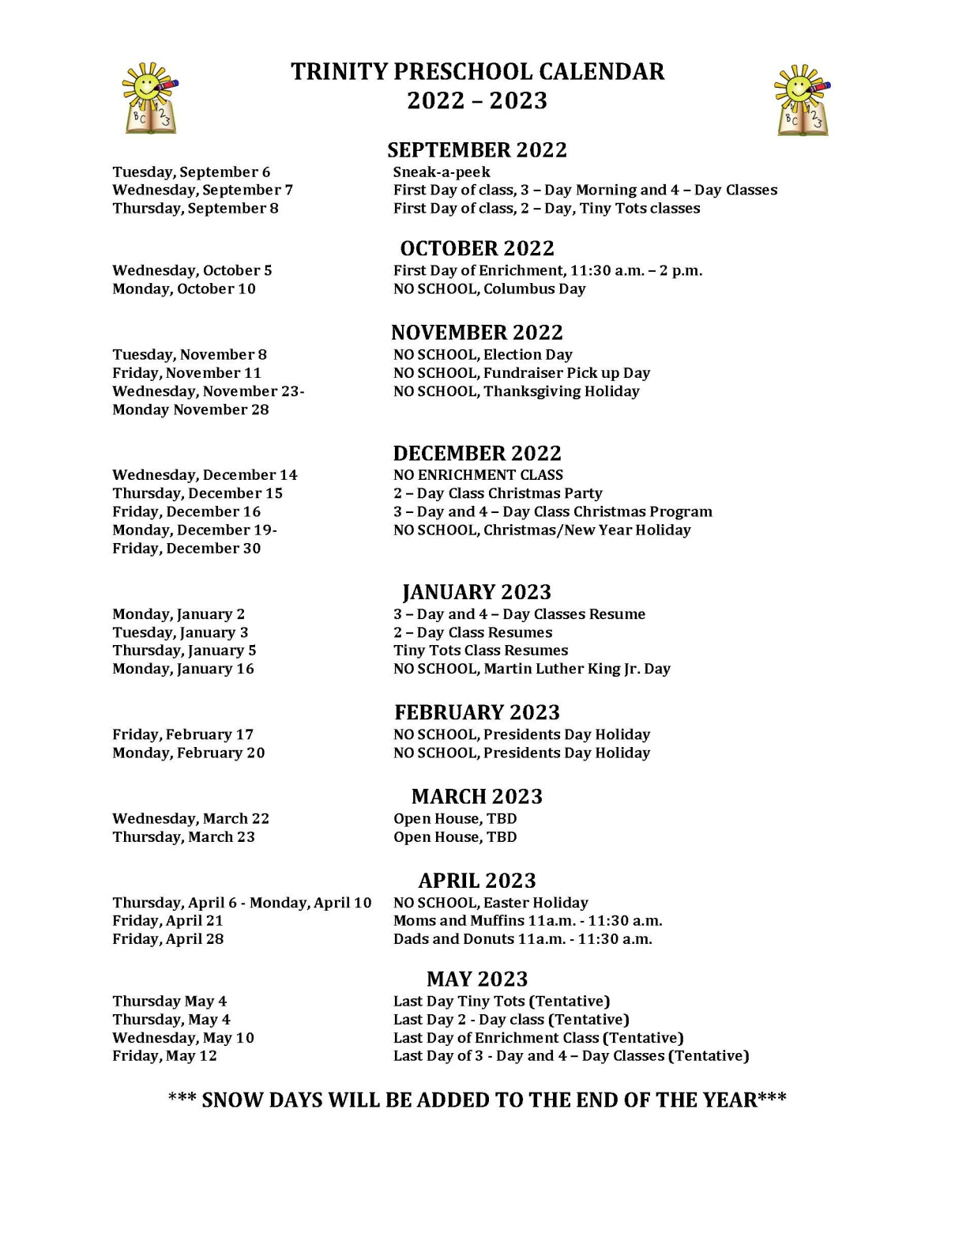

Table of Contents page

Introduction 5
A Big Step 5
Organization 5

Goals 6

Preparing for Preschool 7
Parent(s) Visits 7
Carpools 7

Orientation 8
Telephones 8
Building Access 8

Daily Schedule 9
Learning Games 9

Field Trips 10
Nutrition 10

Toys from Home 11
Clothing 11

Conferences 12
Arrival and Dismissal 12
Authorization to Pick Up Child 12

Health and Safety 13

Late Start or Closing of School 13
Financial Arrangements 14

School Term 15
Auxiliary Services 15
A Caring, Professional Touch 15

Mission Statement 16

INTRODUCTION
This handbook has been prepared for parents so that they may be better acquainted with Trinity Preschool.

We encourage parents to read the handbook and supplemental monthly newsletters which are distributed. We hope that you will become a part of our school by offering suggestions, comments, and constructive criticisms, so that we may continue to improve our programs. Please visit us on Facebook as well!

A BIG STEP
Preschool is probably one of the first experiences your child has had in leaving parents and managing with new adults and children outside the home. Your child still loves and needs family very much. Their healthy social growth is dependent upon having the freedom to develop the skills needed to cope with new situations. Relax, observe and enjoy as your child takes this new step forward.

Show your child the confidence you have that they will be successful in preschool as they enjoy friends and discovery!

ORGANIZATION
Trinity Preschool was established in 1968, and is an outreach commission of Trinity United Church of Christ, East Petersburg.

The school is governed by a Preschool Board which reports directly to the Board of Elders of Trinity United Church of Christ. The Preschool Board consists of six elected members from Trinity's congregation, the Preschool Director, and the Pastor. In addition, parent representatives are voting members of the Board.

Operating expenses for the school come from tuitions and subsidies from Trinity United Church of Christ. Preschool Board meetings are held throughout the year, and are open to those who wish to attend. Please contact the director for the dates.

GOALS Trinity Preschool's goals are to:
1) Help each child to develop a good self image.
2) Help each child to develop a desire for exploration.
3) Help to develop each child's potential.
4) Provide each child the opportunity to:
a. Have first-hand experiences;
b. Physically develop large/small muscles;
c. Find acceptable outlets for emotions
d. Learn and practice self-regulation skills..
5) Encourage self expression.
6) Stimulate language development.
7) Help to develop each child's awareness of the five senses.
8) Encourage independence.
9) Provide basic experiences for future learning.
10) Provide opportunity to develop social skills.
11) Meet the needs of individuals, as well as groups.
12) Encourage a positive attitude toward school and the learning process and be prepared for academic growth.
13) Provide each child with experiences which he/she does not have at home.

PREPARING FOR PRESCHOOL
- Complete the Registration Form and pay the registration fee. This secures enrollment for your child on a first-come, first-served basis.
- Submit the following completed important papers at the beginning of the school year:
a) Physical Examination Report signed by your physician.
b) Permission Slip giving blanket permission for all field trips and use of photographs.
c) Information Report giving us some helpful guidelines for knowing and serving your child.
d) Emergency Form informing us of the person to contact in case of emergency.
- Make or purchase a back pack or tote bag labeled with your child's name (for use when your child carries items to and from school.) A handy size is approximately 12" x 18".

PARENT(S) VISITS
A parent meeting is held each fall to provide an opportunity for parents and the Preschool staff to become better acquainted. Parents at this time also become familiar with our program(s).

Scheduled classroom visitations are offered through posted sign-up sheets. These visits allow parents an opportunity to observe and participate in the classroom activities and perhaps share a special interest with the children.

CARPOOLS
Please give the names of the children and the names of the drivers to the classroom teachers. Teachers need to be introduced to the driver if other than a parent.

ORIENTATION
- Families First Day is a September evening Open House just before the start of school.
- The first day of school is a one hour session. Each child goes to the classroom, while the parents may gather for refreshments and conversation.
- On the second day of School the 3-day classes will have a regular session; the 2-day classes are in session for 1 hour. After that all classes will be in session for 2-1/2 hours.
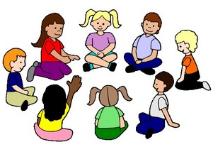
- Familiarize your child with where you will be while he/she is in Preschool. Discuss your activities, and reassure him/her by your demeanor (when you leave and when you reappear) that all is well. It is helpful for your child to know you have confidence in him/her and trust that school is a wonderful place to come!

TELEPHONES
Trinity has two numbers! You may call 569-1632 or 569-0592. Please add these numbers to your contact list. If no one is able to answer, you will be directed to voice mail.

BUILDING ACCESS
To ensure the safety of our children at our Preschool, the doors will be locked during the school day. They will be unlocked for 15 minutes around times of drop-off and pick-up. If you would need to enter the building at other times during the school day, please use the doorbell at the front entrance of our church building. The church secretary or staff member will let you in at this entrance.

DAILY SCHEDULE
Trinity Preschool's daily schedule provides time for both quiet and active experiences. There are opportunities for child-selected, as well as teacher-determined, activities.

There is a great deal of flexibility in the schedule in keeping with: the child's interest level, field trips, holidays, emergencies, weather conditions, and other items which affect the children.

However, the teacher(s) will attempt to establish a framework or routine for the class, which will enable each child to become comfortable with the sequence of events. These events vary with each class. Included in the daily schedule are the following activities:
- Free Play (interest centers including art process, imaginary play, science/math, manipulatives, books and individual attention)
- Clean Up Time
- Large Muscle Development
- Care of Physical Needs (lavatory and washing of hands.)
- Snack
- Circle Time (creative arts, stories, music, finger plays, dramatization, calendar, weather.)
- Small Group (arts and crafts, learning games, language development, Treasure Time, science experiments, math activities, cooperative games.)

LEARNING GAMES
Many teacher-created games are used to stimulate awareness of colors and shapes, distinguishing of similarities and differences, coordination, language skills, the alphabet, early math and science concepts, and beginner reading/writing skills.

With the heavy emphasis on “readiness” for children entering kindergarten, the teachers stay well informed of what that term includes. Curriculum and daily lesson plans include much exposure to the written word, opportunities to practice writing, and experiences to recognize letters and the sounds they make.

FIELD TRIPS
- Experience: After the children begin feeling comfortable with the Preschool group, some classes begin venturing forth on well-planned field trips within the Lancaster County area.
- Notification will be given to children and parents before each trip. Participation is OPTIONAL.
- Transportation is usually by foot or by car. Sign-up sheets will be posted requesting driver/chaperone(s.) It is mandatory for a child to have the use of his/her car seat to ride in a car. Field trips are considered enrichment activities to enhance the learning of lessons being taught in the classroom, but no parent should feel obligated to participate or have the child participate if transportation is a concern.
- Drivers/Chaperones must have appropriate clearances.

NUTRITION
The fun of sharing and eating a snack together is a great learning/social time for the children. Each month a calendar will be sent home with your child’s assigned snack day. The snack will be shared with all the children and teachers in the class. At-home preparation can be a shared time with your preschooler to make or purchase the snack. We encourage nutritious (low sugar, low fat) snacks.

Cooking is included in our activities, adding in many ways to learning experiences. It's also fun to eat what you help to prepare!

Treats: You are welcome to discuss with the teachers your plans about providing treats for birthdays or other events.

TOYS FROM HOME
- Treasure days are noted on class calendars. These are the only days when it is recommended that your child bring a toy from home into the school.
- Books, music, nature items, and homemade items (especially ones the child has helped to make) are enriching items for sharing.
- Guns, war toys, and other toys of destruction are TABOO in our school. A child must have a means to express feelings of aggression. We suggest clay to pound, hammer and nails, punching bag to hit, and finger paints.
- Labeling items with your child's name is helpful.

CLOTHING
- Comfortable, washable, uncomplicated clothing (free of many fastenings) is recommended for activities involving everything from sitting on floors to climbing on climbers. Shoes (like sneakers) that allow your child to move, run, and jump safely are suggested.
- Jewelry and similar accessories tend to be a distraction in the classroom setting and should be discouraged.
- Classrooms tend to be warm and preschoolers tend to be active, so lightweight shirts or sweaters are wise even for winter days.
- Floors tend to be cool and preschoolers tend to sit on them, so slacks or tights give comfort and protection against the cold.
- Outdoor play is part of our program(s) whenever possible. Lightweight sweaters or coats are fine in fall and spring. Warm jackets (with a minimum of extra hats, mittens, and boots) are useful for winter activities.
- Labeling each piece of outdoor clothing with your child’s name is helpful. Adhesive tape is a handy item for this objective.

BIKE HELMETS
For the safety of our Preschool children when they are using any of the outside riding toys, they will need to wear their bike helmets from home. Please send your child’s helmet to school with his/her name clearly marked.

CONFERENCES
Communication between home and school is essential, and a plus for everyone - your child, the parents, and the teachers. Trinity Preschool staff is readily available for personal contact or telephone conversations throughout the year. Fifteen minute conference times will be offered (usually in January or February), and you may sign up for a special time of sharing parent/teacher insights.

ARRIVAL AND DISMISSAL
9:00 AM/12:30 PM ARRIVAL: Please do not arrive too early (not more than 5 minutes ahead of time), allowing the teachers time to prepare the classroom to each child's maximum benefit. Please do not arrive too late, allowing your child to enter his/her group comfortably.

11:30 AM/3:00 PM DISMISSAL: Please notify us if you find that you are going to be detained, allowing us to reassure your child.

AUTHORIZATION TO PICK UP CHILD
NO CHILD WILL BE RELEASED TO A PERSON WHO IS NOT AUTHORIZED BY THE CHILD'S PARENT(S) TO PICK UP THE CHILD. We MUST have written or verbal permission from you. Staff members are not permitted to drive children to and from school, except in emergency situations.

HEALTH AND SAFETY
Your child's health and safety are best guarded when you: Keep your child AT HOME if he/she shows signs of illness such as vomiting, fever, coughing, or mucous discharge from the nose, or head lice (your child would need to remain at home until there are no nits.) This offers protection from the likelihood that the illness will become more severe, and reduces the risk of having other children contract the illness. If your child is absent for more than 3 consecutive days, please bring a note stating why they were absent upon their return to school. Please inform the teach and/or the Director of any absences they day of ASAP, so they are aware of who will not be present for the day. Alert the teachers (teachers alert the parents) concerning exposure to contagious illnesses (such as chicken pox.) Keep teachers posted about any change of information (especially telephone numbers) on your child's Emergency Form. Policies for Health and Safety follow the NAEYC (National Association for the Education of Young Children) and The American Academy of Pediatrics standards. Information regarding Health and Safety issues is available upon request.

LATE START OR CLOSING OF SCHOOL
- Modified snow schedule is as follows: The morning sessions will meet 10:30am-12:30pm when Hempfield School District is delayed. Enrichment Class will be 12:30-2:30 PM. Afternoon 3 Day class will meet 1:00-3:00 PM.
- Make-up days due to inclement weather are scheduled for some holidays during the school year, or at the end of the school year. 3-day classes will make up as many as 6 snow days. 2-day classes will make up as many as 4 snow days.
- Sudden emergency schedule changes will be sent to you via email or text message. PLEASE KEEP US UP TO DATE WITH YOUR EMAIL ADDRESS AND PHONE NUMBER!

FINANCIAL ARRANGEMENTS
Trinity Preschool tuition is based on the actual cost of operating the school, with fees for the coming year based on a nonprofit budget.

REGISTRATION/APPLICATION FEE. A non-refundable fee is payable when you enroll your child. It cannot be included as, or applied toward, the tuition cost.

TUITION FEE. Tuition is due in two, four, or 9 monthly installments. These installments are due promptly. The dates have been established for the convenience of parents. Quarterly due dates are: August 15th, October 15th, January 15th, March 15th. Reminders concerning the due dates will be placed in the monthly newsletters. Your cancelled check is your receipt. Bi-annual payments are due August 15th and January 15th; monthly payments are due August 15th, September 15th, October 15th, November 15th, December 15th, January 15th, February 15th, March 15th, and April 15th. A $30.00 charge will be added to late payments after one week. Parents are responsible for bank charges if occurred due to returned checks.

SCHOOL TERM
1-day Class – 31 school days
2-day Class – 63 school days
3-day Class – 92 school days
Enrichment – 28 school days
4-day Class – 124 school days

EARLY WITHDRAWAL: Each child is enrolled for the entire school year. The policy for early withdrawal from school is that NO REFUNDS ARE GIVEN. However, this policy may be appealed, with justification, by written request to the Preschool Board.

AUXILIARY SERVICES
Trinity Preschool has access to many consulting services which will be used as necessary after parent/teacher discussion. These services include:
Speech analysis
Vision analysis
Hearing analysis
Emotional analysis
Coordination analysis

A CARING, PROFESSIONAL TOUCH
Trinity Preschool's Director and Head Teachers are highly qualified with years of experience and enjoyment in both teaching and parenting roles.

Assistant teachers are experienced in parenting and are chosen on the basis of skill and sensitivity in working with children.

NAEYC(National Association for the Education of Young Children) & PACCA(Pennsylvania Child Care Association) are the professional groups in which the school actively participates, continually learning how to best serve your child and you!

MISSION STATEMENT
Trinity United Church of Christ Preschool provides
an environment for Christian nurturing, fellowship
and socio-emotional development for
preschool children.

