Trinity Preschool

Papers to be completed before start of camp

&

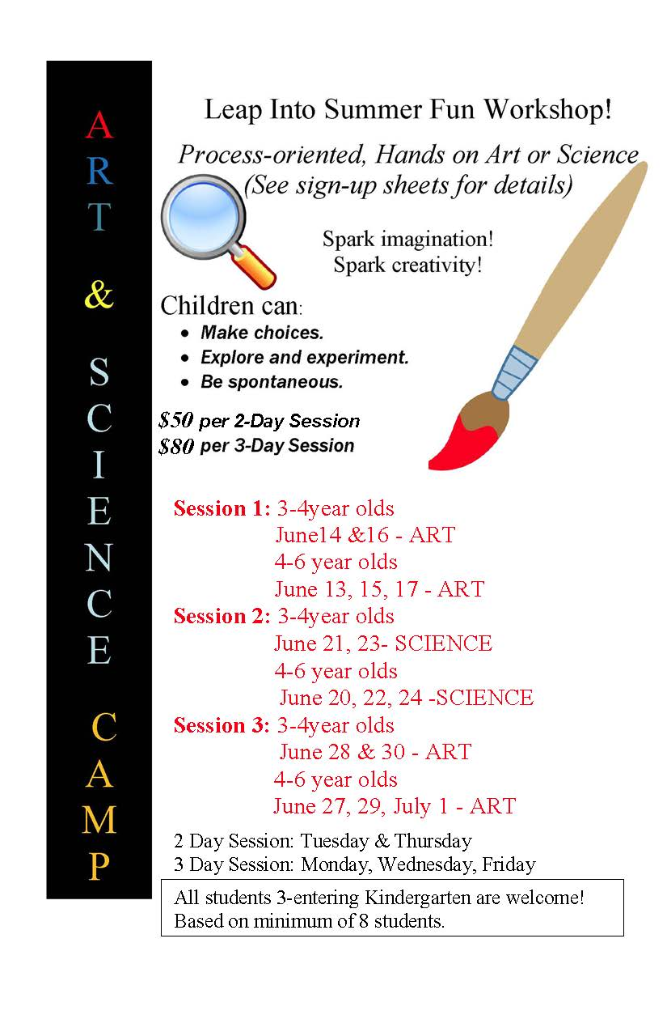 Amt Enclosed
Session 1: 3-4year olds
June14 &16 – ART _______________________
4-6 year olds
June 13, 15, 17 – ART _______________________
Session 2: 3-4year olds
June 21, 23- SCIENCE _______________________
4-6 year olds
June 20, 22, 24 –SCIENCE _______________________
Session 3: 3-4year olds
June 28 & 30 – ART _______________________
4-6 year olds
June 27, 29, July 1 – ART _______________________

TOTAL ____________
BASED ON MINIMUM OF 8 STUDENTS

Name of Student ________________________
Address ________________________
________________________
Phone Number ________________________

(next page)

Trinity UCC Preschool
2340 State Street
East Petersburg, PA 17520
569-1632 569-0592

EMERGENCY FORM

Child’s Name _______________________________Child’s Birthdate_________

Child’s age as of September 1st ________

Parent(s)’ Name(s)________________________________________________

Address _________________________________________________________

Phone Number ___________________ Cell Phone(s) _____________________

E-mail Address ___________________

Father’s Occupation/ Place of employment______________________________

Type of work _____________________Work Phone Number _______________

Mother’s Occupation/Place of employment ______________________

Type of work __________________________ Work Phone Number __________

The best person to be reached in an emergency _________________________

Telephone Number _________________

Alternate Telephone Numbers
Relationship
Name Number to Child

1. ________________________ _____________ _______________

2. ________________________ ____________ _______________

3. ________________________ ____________ _______________
(next page)

Family Doctor ____________________________________________________

Address _________________________________________________________

Telephone Number ___________________

Allergies ________________________________________________________

________________________________________________________________

Hospital Preference______________________________________________________

Comments ______________________________________________________

_______________________________________________________________

_____________________________________ _______________
Signed Date

(next page)

Trinity UCC Preschool
2340 State Street
East Petersburg, PA 17520
569-1632 569-0592

PERMISSION FORM

Child’s name ___________________________________________________

I hereby grant permission for my child to use all of the play equipment, and participate in all of the activities of the school.

I hereby grant permission for my child to leave the school premises, under the supervision of a staff member, for neighborhood walks or field trips, in an authorized vehicle. I will receive notification prior to each field trip, and I will provide an appropriate car safety seat for the trip or I will keep my child home the day of the field trip.

I hereby grant permission for my child to be photographed participating in school activities and for these photographs to be used for display, publicity, and school projects.

I hereby grant permission for the Director or teacher to take whatever steps may be necessary to obtain emergency medical care if warranted. These steps may include, but are not limited to, the following:

1. Attempt to contact a parent or emergency call number.

2. Attempt to contact the child’s physician.

3. If we cannot contact you or the child’s physician, we will do any or all of the following:

a) Call another physician;
b) Call an ambulance;
c) Have the child taken to the emergency room at the closest hospital, accompanied by a staff member.

4. Any expenses incurred, under #3 above, will be borne by the child’s family.
(next page)

5. The school will not be responsible for anything that may happen as a result of false information given at the time of enrollment.

6. The school will not assume responsibility for a child who has not been properly walked to the classroom by the parent or carpool driver.

_________________________________________________________________________________________________
Parents name (printed)

_________________________________________ _______________
Signed Date

