November 2019

TRINITY UCC

PRESCHOOL

NEWSLETTER

FUNDRAISER – HOLIDAY PIES! Pick-up day for pies – Friday, November 5th 10:30 A.M. to 1 P.M. There will be NO SCHOOL that day. Payment is expected at the time of pick-up if you have not already paid. These pies can be frozen and used at any time. Thank you for your support! We sincerely appreciate your time!

ELECTION DAY: TUESDAY, NOVEMBER 2nd, Trinity Church will be used as polling place this year. There will be NO SCHOOL that day.

COMMUNICATION: We would like to be sure we have an effective way to reach you in an emergency causing a schedule change or alert. We will use a text message. Please be sure to leave the phone number that you prefer we use. Thank you for providing accurate information to help us communicate with you!

GIVE THANKS: At Trinity Preschool there are 34 children and we are very thankful to have them as a part of the school! We hope this Thanksgiving will be filled with special moments for all of you and your families! Happy Thanksgiving from your preschool staff!

FROM A PRESCHOOLER’S POINT OF VIEW:
When I participate in circle time activities, I am learning:
• to listen and understand spoken language. •. the names of others in the group.
• to add my ideas to the discussion. My ideas have value. • to cooperate and be considerate of others. . • new vocabulary connected with the topic. • to help plan what we will do next.
• to remember the words of songs and poems. • self-control.

SELF ESTEEM: By now, your child has become comfortable with his/her school, teachers, and new friends. What a wonderful accomplishment! Some children have had some rough moments, some have adjusted easily, some may show some difficulty later in the year. Whatever the case, parents can feel great about giving their child this opportunity to grow, learn, and to succeed at something all their own. Your child’s confidence is growing and self esteem is a great predictor of future success!

FACEBOOK: Trinity Preschool is on Facebook! Periodically, the director will post events that have already happened or helpful information to parents and caregivers. Our purpose for using this media is to inform you and the community of this rich, fun, nurturing place for growing children. Parents have signed our permission form relating to the use of photos. PLEASE INFORM US personally if you would prefer your child NOT to be on the Facebook page. No names will be used ever! Like us on Facebook!

SPECIAL DATES
Tuesday, November 2 NO SCHOOL Election Day
Friday, November 5 NO SCHOOL Pie Pick-Up 10:30A.M.-1 P.M.
Thursday, November 15 MONTHLY TUITION DUE
Wednesday, November 25 – Monday, November 30 NO SCHOOL Happy Thanksgiving!

4-day Class: October was wonderful and we are looking forward to a fun filled November! We will be learning about Thanksgiving, turkeys, and life on the farm! We will also have a silo as an extension of our outdoor classroom to go with our farm theme.

3-day Class: October was so much fun and we are looking forward to November. We will be exploring the numbers 10-15, the color brown and the rectangle shape. We will talk about Thanksgiving, being thankful, homes, friends and families. We will have lots of hands-on experiences with farm play.

2-day Class: November already! We are thankful to be together with friends in the 2-day class! We will be talking about Thanksgiving, and giving thanks. We will explore the color brown and rectangles. Happy Thanksgiving!!!

Tiny Tots: Wow! Only a short 8 weeks and these Tiny Tots have grown so much already! The children are getting settled into our school routine and learning more and more each week. This month we will be going "down on the farm". Our color this month will be brown!

THINK ABOUT THIS! A mother is not a person to lean on, but a person to make leaning unnecessary. Dorothy Canfield Fisher

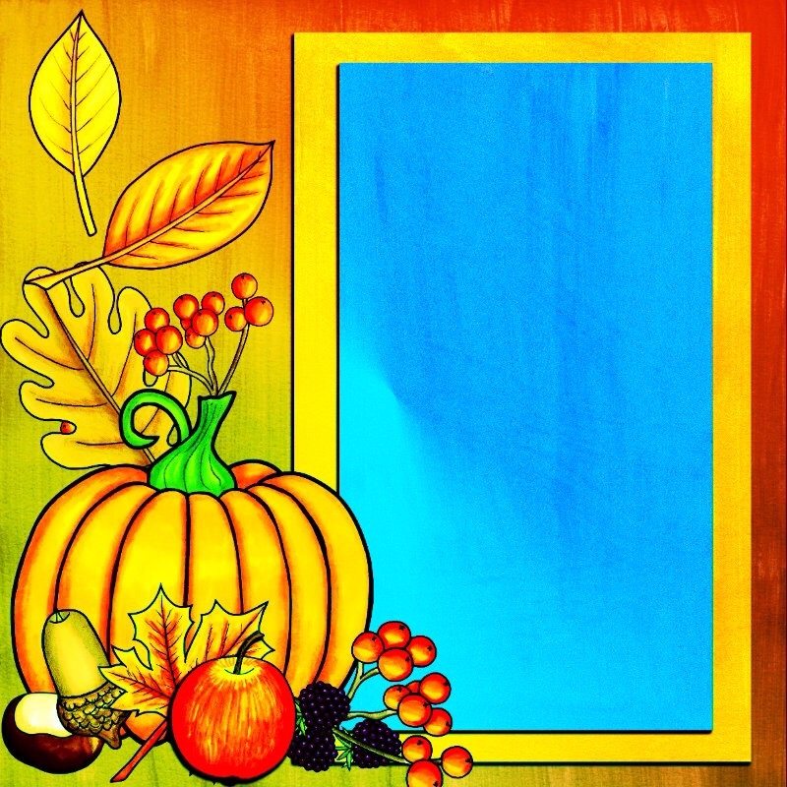

Happy
Thanksgiving

